STEVE BIKO HOUSING ASSOCIATION GAS SAFETY POLICY AND PROCEDURES

APPROVED: 22 February 2016 DATE FOR REVIEW: February 2017

PART A.

Aim

Policy
GAS SAFETY POLICY

The aim of this policy and procedure is to define the operational procedures to be undertaken by our agents and ourselves to ensure that Steve Biko Housing Association conforms to the relevant sections of the Gas Safety (Installations & Use) regulations 1998. The policy is referred to as Steve Biko Housing Association (SBHA) Gas Safety Policy and Procedure.
In addition to our overall aim we will:

  - Ensure that the inspection and service is cost-effective and carried out to the highest standards
  - Ensure that gas inspections and services are completed in accordance with current law and best practice.
  - Survey customers views on the service they receive; take action to remedy any problems and us the results to continually improve our policies and procedur es.

Scope
  - Steve Biko Housing Associations Policy and Procedure applies to all general needs and sheltered housing schemes and includes domestic and commercial installations.
  - All contractors must follow these procedures at all times.
  - SBHA Gas Servicing Standard is as follows:
"We will ensure that all gas appliances and installations are checked at least every 12 months".
  - This policy and associated procedures clarifies to all staff and Agents of SBHA and sets out how SBHA will seek to:
    - Comply with legislation
    - Minimise the risk associated with SBHA gas appliances
    - Ensure that the gas appliances supplied by SBHA work efficiently
    - Ensure that tenants own gas appliances do not constitute a safety hazard

Principles of the Policy
  - To establish the process for compliance with the Gas Safety (installation and use) Regulations 1998
  - To ensure compliance under statutory obligations under the Health and Safety at Work Act 1974 and the Management of Health and Safety at Work Regul ation s (MHSWR) 1999
  - To demonstrate compliance with the HSE legal environment and that all reasonable steps have been taken
  - To remove financial, personal and corporate risk from SBHA's day to day delivery.

Legal and Regulatory Requirements.

There is an extensive amount of law on Gas Servicing requirements including:

  - The Landlord and Tenant Act 1985
  - The Health & Safety at Work Act 1974
  - The Gas Safety (Installation and Use) Regulations 1998
  - Reporting of Injury, Diseases and Dangerous Occurrences
  - Landlord and Tenant Act
  - Occupiers Liability Act
  - Gas Safety (Management) Regulations
  - Gas Appliances (Safety) Regulations
  - Gas Safety (right of Entry) Regulations

We will comply with all legal requirements and with HSE Codes of Practices and Guidelines.

Gas Safety (installation and Use) Regulations 1998 place responsibilities on persons servicing and repairing gas appliance and landlords as follows:-
  - Ensure persons doing gas work are 'Gas Safe' Registered
  - Not to use or permit the use of unsafe appliances
  - Ensure safe maintenance of gas appliances, flues and installation pipework
  - Ensure an Annual Gas safety check is carried out; and to;
  - Record, keep records and issue copies to tenants

Monitoring, Review and Evaluation
The policy will be reviewed annually.

  - KPl's and board reports are compiled quarterly for monitoring purposes and to allow evaluation and review of the effectiveness of the policy. KPl's are monitored monthly at an operational level at joint meetings with SBHA's agents.
  - The gas service records will be stored and administrated by the Agents of SBHA.

Related documents
This procedure will be linked to the management documents for Voids [relets standards]

This procedure will be supported by the detailed schedule for servicing requirements contained within the all -inclusive service contract.
This policy will be read in conjunction with "Safety in the Installation and use of gas system and appliances" published by the HSE. This provides practical guidance with respect to the provisions of the gas safety [installation and use] Regulations 1998. It has the status of being the HSE's code of practice in regard to gas safety. Latest versions published 2004.
This policy will be read in conjunction with "Gas Safety Review - Proposals for Change" HSE. ht t p:// www.hse.gov.uk/gas/domestic/change.pdf
This policy will be read in conjunction with "A guide to landlords' duties: Gas Safety [Installation and Use]"

General

SBHA requires that Certificates must be issued whether or not gas exists or is used at any of the following types of properties:
- Type A Full gas carcass and appliances
- Type B Full gas carcass, where there are no appliances
- Type C No gas to property (A property being anything other than a block).

SBHA is not responsible for undertaking a Gas Safety Check on the following properties:

- Type D -A block of flats where there is no gas supply to the building.

Gas Safety Checks
SBHA are responsible for carrying out an annual gas safety check to our properties and must provide evidence of this by issuing a Landlord Gas Safety Certificate. A registered Gas Safe engineer will carry out these checks. SBHA will also carry out a Gas Safety Check every time the status of a property or its tenancy changes. This is usually when a property becomes empty (void) or when a mutual exchange takes place.

Gas Servicing

The safety checks will include full servicing of all the appliances owned by SBHA. This will be recorded on the Landlord Gas Safety Certificate. Servicing and checks must be carried out on or before the expiry date of the current cert ificate. Servicing dates are planned for approximately six weeks before the expiry of the current certificate to ensure that adequate time is allowed for missed appointments, no access and if necessary legal action.
Final letter to tenants requesting access to carry out servicing will be sent recorded delivery or hand delivered and witnessed to delivery.

Risk

The risk factor in delivering this service is high, contravention of the regulations and delivery requirements is an offence and can/will result in fines, imprisonment and possibly loss of life. A charge of Corporate Manslaughter could be levied with any failure that leads to loss of life.

STEVE BIKO HOUSING ASSOCIATION - GAS SERVICING PROCEDURE

PROCEDURES | RESPONSIBILITY
The Agent will prepare and manage a full and detailed schedule of the associations properties for the service provision | Agent
It is the responsibility of SBHA to inform the agent of any acquisitions,  conversations or changes to Right to Buy/Right to Acquire/leaseholder etc. The schedule will be available for SBHA inspection. | SBHA
SBHA currently operates a 10 month cycle of servicing. This requires each units' anniversary to be brought forward 1 month every year. For properties that have historically been difficult to access a 10 month programme will be implemented.  The agent will be responsible for the set up and delivery of this schedule. | Agent
The agent will ensure that the contractor notifies all SBHA tenants six weeks by letter, in advance of the intended servicing dates with relevant contact details | Agent
Customer contact will be recorded against Gas Service Contractor receiving the call. Or if they tenant contacts SBHA/Agent direct on their system records. | Contractor Agent SBHA
On access the engineers will carry out a full and detailed gas service as per  relevant trade and manufactures requirements. Full consideration and attention will be given to Gas Safe requirements and relevant legislation provisions. | Contractor
Engineers will complete LGSR on completion, one copy will be left with the tenant. | Contractor
The Agent will be responsible for capturing all reports of condition, notification of failure or replacement. The information will be communicated to SBHA Finance to ensure the information is populated within the asset register. The Agent will be responsible for raising any orders and ensuring the works are completed to the safety of the tenant. All details will be recorded for audit purpose' individual
reports should be scanned against individual properties.
Engineers will card all properties where access has not been successful (3 times). Evidence of attendance where no access has been obtained should be recorded and supplied to SBHA if evidence is required to support legal action to keep on
individual files.
The Agent shall update records on a regular basis (minimum weekly) in order to
record successful service and or initiate access procedures.
All LGSR should be scanned in an auditable method.
Robust Access Procedures to Gain Access. SBHA have a robust procedure to gain Access to dwellings to undertake Gas Servicing including:
- Tenants communication needs to be taken into account when contacting
tenant, e.g. language, disability, age
- Good record of attempts to gain access with details of date and time and person(s) attempting access
- Gas Safety Inspection anniversary noted and appointment letter sent to tenant six weeks before LGSR due date by the contractor
- Contractor will make 3 attempts to gain access
- Follow up procedures to gain access following initial 3 attempts.
No Gas Supply
In all cases of notification of "No Gas Supply" the Agent will record this on the system.
s

PROCEDURES | RESPONSIBILITY
Audit
The Agent will carry out a weekly audit of all paperwork and ensure the service programme is up to date.

The Agent will carry out regular liaison meetings to determine factual reporting and recording of data. Issues around processes will be discussed and resolved.

The Agent will keep Gas Servicing as a standard agenda item for SBHA/Agent operational monthly meetings to report progress, access and legal proceedings.

The Agent will carry out quarterly audits of the above process.

The Agent will ensure that a 5% telephone customer satisfaction sampling is carried out by telephone. The details will be recorded and reported to SBHA via monthly operational meetings.

SBHA internal audit will test the gas service provision and delivery on a two yearly basis.
Reporting Structures

The Agent will be responsible for ensuring records are updated on a weekly Basis. The Agent will be responsible for producing monthly reports. Reports will be presented to monthly operation s meetings, and will be reported by exception, (properties where no access has been gained.)

The Agent will produce information to be includedwithin quarterly KPI report s to Board.

The Agent will provide monthly reports to SBHA on the number of customer satisfact ion calls made by the agent and conformity with 5% requirement.
Gas Repairs and Out of Hours

The Agent will be responsible for ensuring that the repair reaction times match SBHA's policies and procedures for reactive repairs.

The Out of Hours repairs service is contracted by the Agent and forms part of the Agent responsibility to ensure performance is monitored and acted upon.
Void Process

Every SBHA prope rt y at void status will be capped off and a visual examination of the equipment undertaken.

Every new let will have a gas soundness test carried out at tenancy start and a
new LGSR issued. The Agent will be respon sible for updating the service schedule .

STEVE BIKO HA GAS SAFETY CHECK- NO ACCESS PROCEDURES 2015
Robust Access Procedures to Gain Access. SBHA have a robust procedure to gain Access to dwellings to undertake Gas Servicing including:
- Tenants communication needs to be taken into account when contacting
tenant, eg language, disability, age
- Good record of attempts to gain access with details of date and time and person(s) attempting access
- Gas Safety Inspection anniversary noted and appointment letter sent to tenant six weeks before LGSR due date by the contractor.
- Contractor will make 3 attempts to gain access
- All gas access information should be returned to Agent by the next
working day.
- If no access gained !5¹ attempt, No Access card left with date/time of first visit, and details for 2nd appointment visit within 5 days.
- If access is not gained, no access card left with date and time of visit and details for 3rd appointment within 3 days.
- Follow up procedures to gain access following initial 3 att empt s, in cluding:
0 Agent to contact by telephone within 2 working days of report from contract or . Agent to liaise with SBHA to establish any tenant issues, vulnerabilit y, legal action etc. (by e-mail)
0 Letter from agent to tenant (Access letter 2.) givingnotification of the need to arrange date/ time for final appointment , also informing of legal action and legal costs if no access gained. Allowing 7 days for tenant to respond. Letter to be hand delivered and delivery wit nessed.
0 Phone call from SBHA advising access is required (allowing 24 hours for tenant to respond)
0 1 visit from agent/ or SBHA staff member (within 5 working days of phone call)
0 Where tenant is vulnerable and no access is still an issue contact with next of kin
0 Letter from SBHA to tenant confirming attempts of contact and no access request urgent response 7 days (Access letter 3)

- Process for implementing legal action where access is not obtained:
0 The Agent will instruct SBHA solicitors to send a warning letter of imminent injunction proceedings, to the tenant.
0 If no access has been gained within 7 days of the sending of the solicitor's lett er, notification will be sent to the solicitors to commence with the injunction process. As part of the injunction process SBHA solicitors will instruct for papers to be served directly to the tenant.
- All attempts to access the property, and where alternative communication
needs have used these have to be recorded on SASSHA /house file
- All legal costs incurred whilst trying to gain access will be recovered from the tenant.

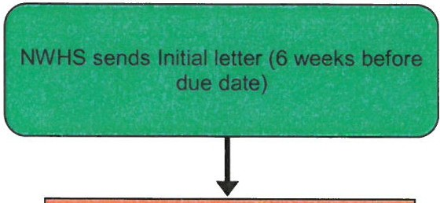

Contractor will write to tenant requesting access

Contractor will attempt access on 3 occasions

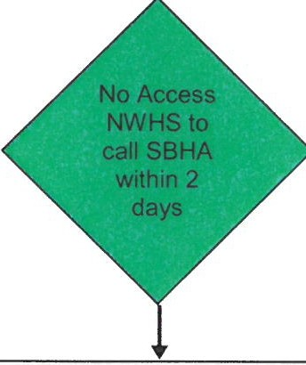Letter from NWHSto tenant

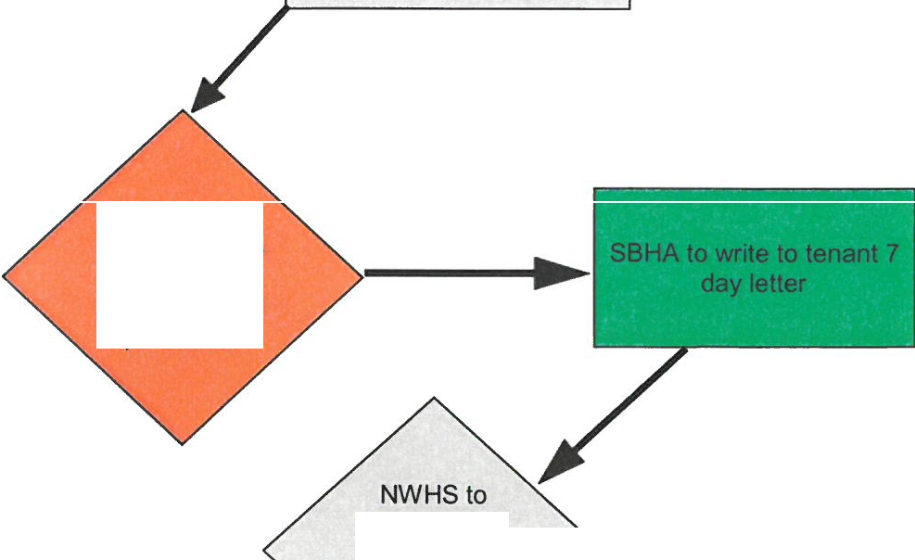SBHA to call tenant within 2 days if tenant has not responded to NWHS letter

SBHA to visit tenant within 5 days if no response from phone call

instruct solicitor to send warning
letter

